

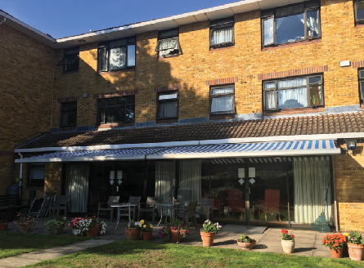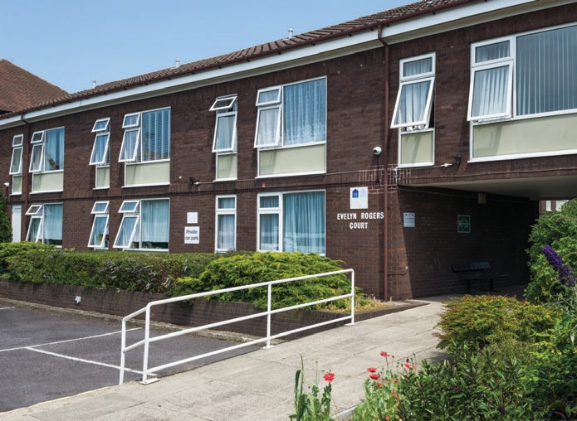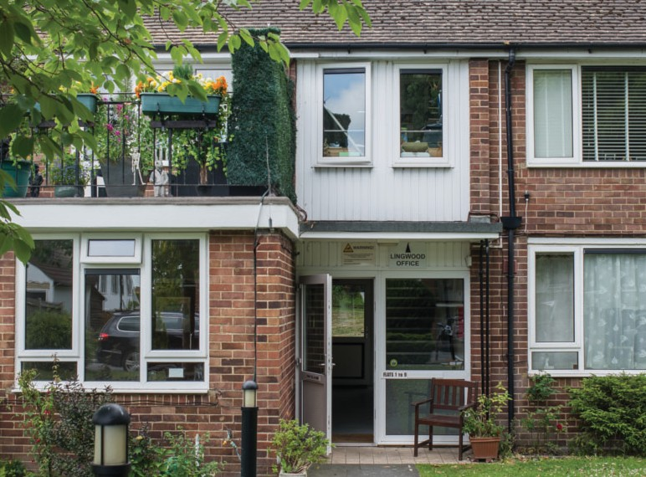**Housing Application Form**

|  |
| --- |
| Please complete this form fully and return it to:- |
| 🖆CSHA, 45 Invicta Close, Chislehurst, Kent, BR7 6SJ 📧 csinfo@csha.org.uk |

1) Contact details

|  |  |  |  |  |
| --- | --- | --- | --- | --- |
|  | **Applicant 1** | | **Applicant 2** | |
| Title (Mr/Mrs/Ms/Mx) &  full name |  | |  | |
| Address |  | |  | |
| Postcode |  | |  | |
| How long have you lived at this address? | Years | Months | Years | Months |
| Please tick if you are homeless and this is a correspondence address | 🞎 | | 🞎 | |

2) Personal details

|  |  |  |
| --- | --- | --- |
|  | **Applicant 1** | **Applicant 2** |
| Date of birth |  |  |
| National Insurance number |  |  |
| Home phone number |  |  |
| Mobile number |  |  |
| Other contact number |  |  |
| Email address |  |  |
| How would you prefer to be contacted? |  |  |

3) Right to rent status

Please tick what right you have to rent in the UK.

This is based on your immigration status. We will require proof of this.

|  |  |  |
| --- | --- | --- |
|  | **Applicant 1** | **Applicant 2** |
| Unlimited |  |  |
| Time-limited |  |  |
| Discretionary |  |  |
| No right to rent |  |  |

4) Next of kin

|  |  |  |
| --- | --- | --- |
|  | **Applicant 1** | **Applicant 2** |
| Title (Mr/Mrs/Ms/Mx)  and full name |  |  |
| Relationship to you |  |  |
| Mobile number |  |  |
| Other phone number |  |  |
| Email address |  |  |

5) Disabilities and/or support

|  |  |  |
| --- | --- | --- |
|  | **Applicant 1** | **Applicant 2** |
| Please list any physical or mental disabilities you have, long-term illnesses that affect your day-to-day living, important treatment for serious illness e.g. (current cancer treatment) and any life-threatening allergies. |  |  |
| Please list any care and support you currently receive. |  |  |
| Please state anything we can do to make communicating with you easier. This includes anything at interview, e.g. translation, large print. |  |  |

6) Medication currently prescribed/taken

Please give brief details, such as the medication name and what this is taken for

|  |  |
| --- | --- |
| **Applicant 1** | **Applicant 2** |
|  |  |
|  |  |
|  |  |
|  |  |
|  |  |
|  |  |
|  |  |
|  |  |
|  |  |
|  |  |
|  |  |
|  |  |
|  |  |
|  |  |

7) Help with this form

Please tell us if someone other than the Applicant(s) has helped by filling out this form.

|  |  |  |  |  |
| --- | --- | --- | --- | --- |
| Someone other than applicant(s) has filled in form (tick) |  | Yes |  | No |
| **If Yes, please give further information below** | | | | |
| Name: |  | | | |
| Relationship to Applicant(s): |  | | | |
| Preferred contact details: |  | | | |
| Brief reasons why they helped with the form: |  | | | |

8) Where would you like to live?

Please tick all schemes you would consider

|  |  |  |  |  |  |
| --- | --- | --- | --- | --- | --- |
|  | Bertha Hollamby Court  Sidcup  (Borough of Bexley) |  | Lingwood  Bexleyheath  (Borough of Bexley) |  | Ursula Lodges  Sidcup  (Borough of Bexley) |
|  | Blackmore House  Forest Hill  (Borough of Lewisham) |  | Evelyn Rogers Court  Mottingham  (Borough of Bromley) |  | Bushell Way Site  Chislehurst  (Borough of Bromley) |

9) Which floor(s) would you need or prefer?

Please tick all that apply.

|  |  |  |  |  |  |  |  |  |
| --- | --- | --- | --- | --- | --- | --- | --- | --- |
|  | Ground |  | 1st |  | 2nd or top | |  | No preference |
| Would you need a lift? | |  | Yes |  | No |  | | |

10) How many bedrooms do you need?

Please tick.

We will only consider joint applicants for two bedrooms; this must be on medical grounds and supporting evidence is required.

|  |  |  |  |
| --- | --- | --- | --- |
|  | 1 |  | 2 |

11) About where you live now

Please tick and complete as indicated

|  |  |  |  |  |  |  |  |  |
| --- | --- | --- | --- | --- | --- | --- | --- | --- |
|  | **Applicant 1** | | | | **Applicant 2** | | | |
| What type of tenure (living arrangement) do you have? |  | Tenant in private rented sector- rent whole property | | |  | Tenant in private rented sector- rent whole property | | |
|  | Tenant in private rented sector- rent a room | | |  | Tenant in private rented sector- rent a room | | |
|  | Social housing tenant-  general needs | | |  | Social housing tenant-  general needs | | |
|  | Sheltered or supported housing | | |  | Sheltered or supported housing | | |
|  | Extra care housing | | |  | Extra care housing | | |
|  | Care or nursing home | | |  | Care or nursing home | | |
|  | Lodger/Living with friends/family | | |  | Lodger/Living with friends/family | | |
|  | In accommodation tied to job | | |  | In accommodation tied to job | | |
|  | Owner-occupier  (If currently owned or you have sold, you will need to provide proof of the equity you own or provide a copy of the completion statement) | | |  | Owner-occupier  (If currently owned or you have sold, you will need to provide proof of the equity you own or provide a copy of the completion statement) | | |
|  | Hostel or temporary accommodation | | |  | Hostel or temporary accommodation | | |
|  | Rough sleeping | | |  | Rough sleeping | | |
|  | Other (please state):- | | |  | Other (please state):- | | |
| What type of property do you live in? |  | House | | |  | House | | |
|  | Flat | | |  | Flat | | |
|  | Bungalow | | |  | Bungalow | | |
|  | Bedsit | | |  | Bedsit | | |
|  | Bed and Breakfast | | |  | Bed and Breakfast | | |
|  | Hostel/Refuge | | |  | Hostel/Refuge | | |
|  | Other (please state):- | | |  | Other (please state):- | | |
| What floor(s) do you use? |  | | | |  | | | |
| Do you pay rent? |  | Yes |  | No |  | Yes |  | No |
| How much rent does your landlord charge? How often (e.g. weekly, calendar monthly)? |  | | | |  | | | |
| How much rent do you personally pay (after Housing benefit etc)? |  | | | |  | | | |
| Details of owner, landlord or managing agent | | | | | | | | |
| Name & address |  | | | |  | | | |
| Phone number |  | | | |  | | | |
| Email address |  | | | |  | | | |

12) Do you have pets?

Please tick: note that we have a no-pets policy; successful applicants must confirm that they are willing to rehouse pets before any offer of accommodation can be made.

|  |  |  |  |  |  |
| --- | --- | --- | --- | --- | --- |
|  | No |  | Yes |  | If Yes, confirm willingness to rehouse |

13) Why you need to be rehoused

Please give brief details of the reason(s). We may ask for supporting evidence.

|  |  |  |  |  |  |  |  |  |
| --- | --- | --- | --- | --- | --- | --- | --- | --- |
|  | **Applicant 1** | | | | **Applicant 2** | | | |
| Home too large / too small |  | | | |  | | | |
| Home in need of major repair |  | | | |  | | | |
| Health reasons |  | | | |  | | | |
| To give or receive care |  | | | |  | | | |
| Suffering violence, domestic abuse or anti-social behaviour/harassment |  | | | |  | | | |
| Subject to immigration controls |  | | | |  | | | |
| Asked to leave by landlord or family/friends in next 56 days  We will require written evidence that you have been asked to leave. For example, a legal notice or a letter from family or friends. |  | | | |  | | | |
| Asked to leave by landlord or family/friends - have longer than 56 days to vacate, or no time given.  We will require written evidence that you have been asked to leave. For example, a legal notice or a letter from family or friends. |  | | | |  | | | |
| To take up work |  | | | |  | | | |
| Local connection, e.g. to be nearer to family or work |  | | | |  | | | |
| Homeless |  | | | |  | | | |
| Current or former member of the Armed Forces |  | | | |  | | | |
| Affordability |  | | | |  | | | |
| Other (please give details), or comments:- |  | | | |  | | | |
| Are you currently on a local authority list for rehousing? Please tick. Proof of this may help with your application. |  | Yes |  | No |  | Yes |  | No |
| If Yes, please state details, e.g. the local authority, reference number, date added and priority/banding you have received. |  | | | |  | | | |

14) Previous addresses

Please give all your addresses over the past five years and continue overleaf and on a separate sheet if needed.

If you left because you sold a property, please provide a completion statement.

|  |  |  |  |  |  |  |  |  |  |  |  |  |  |  |  |  |  |  |  |
| --- | --- | --- | --- | --- | --- | --- | --- | --- | --- | --- | --- | --- | --- | --- | --- | --- | --- | --- | --- |
|  |  | **Applicant 1** | | | | | | | | | **Applicant 2** | | | | | | | | |
| 1. | Full address |  | | | | | | | | |  | | | | | | | | |
| Postcode |  |  |  |  | |  |  |  |  |  |  |  |  | |  |  |  |  |
| Dates at address | From: | | | | To: | | | | | From: | | | | To: | | | | |
| Status, e.g. tenant, owner (see About Where You Live Now) |  | | | | | | | | |  | | | | | | | | |
| Were you responsible for rent payments? | Yes | |  | | | No | |  | | Yes | |  | | | No | |  | |
| If Yes, how much rent did you personally pay (after Housing Benefit or housing element of Universal Credit) and how often? |  | | | | | | | | |  | | | | | | | | |
| Reason for leaving |  | | | | | | | | |  | | | | | | | | |
| Landlord’s contact details (name of individual or company, address and other contact details) |  | | | | | | | | |  | | | | | | | | |
| 2. | Full address |  | | | | | | | | |  | | | | | | | | |
| Postcode |  |  |  |  | |  |  |  |  |  |  |  |  | |  |  |  |  |
| Dates at address | From: | | | | | To: | | | | From: | | | | | To: | | | |
| Status, e.g. tenant, owner (see About Where You Live Now) |  | | | | | | | | |  | | | | | | | | |
| Were you responsible for rent payments? | Yes | |  | | | No | |  | | Yes | |  | | | No | |  | |
| If Yes, how much rent did you personally pay (after Housing Benefit or housing element of Universal Credit) and how often? |  | | | | | | | | |  | | | | | | | | |
| Reason for leaving |  | | | | | | | | |  | | | | | | | | |
|  | Landlord’s contact details (name of individual or company, address and other contact details) |  | | | | | | | | |  | | | | | | | | |

Previous addresses (continued )

|  |  |  |  |  |  |  |  |  |  |  |  |  |  |  |  |  |  |  |  |
| --- | --- | --- | --- | --- | --- | --- | --- | --- | --- | --- | --- | --- | --- | --- | --- | --- | --- | --- | --- |
|  |  | **Applicant 1** | | | | | | | | | **Applicant 2** | | | | | | | | |
| 3. | Full address |  | | | | | | | | |  | | | | | | | | |
| Postcode |  |  |  |  | |  |  |  |  |  |  |  |  | |  |  |  |  |
| Dates at address | From: | | | | To: | | | | | From: | | | | To: | | | | |
| Status, e.g. tenant, owner (see About Where You Live Now) |  | | | | | | | | |  | | | | | | | | |
| Were you responsible for rent payments? | Yes | |  | | | No | |  | | Yes | |  | | | No | |  | |
| If Yes, how much rent did you personally pay (after Housing Benefit or housing element of Universal Credit) and how often? |  | | | | | | | | |  | | | | | | | | |
| Reason for leaving |  | | | | | | | | |  | | | | | | | | |
| Landlord’s contact details (name of individual or company, address and other contact details) |  | | | | | | | | |  | | | | | | | | |
| 4. | Full address |  | | | | | | | | |  | | | | | | | | |
| Postcode |  |  |  |  | |  |  |  |  |  |  |  |  | |  |  |  |  |
| Dates at address | From: | | | | | To: | | | | From: | | | | | To: | | | |
| Status, e.g. tenant, owner (see About Where You Live Now) |  | | | | | | | | |  | | | | | | | | |
| Were you responsible for rent payments? | Yes | |  | | | No | |  | | Yes | |  | | | No | |  | |
| If Yes, how much rent did you personally pay (after Housing Benefit or housing element of Universal Credit) and how often? |  | | | | | | | | |  | | | | | | | | |
| Reason for leaving |  | | | | | | | | |  | | | | | | | | |
|  | Landlord’s contact details (name of individual or company, address and other contact details) |  | | | | | | | | |  | | | | | | | | |

15) Where you first heard about us

If this was from a CSHA tenant- please give details such as their name and address if known; if you begin a tenancy with us, we will give them a token of our thanks.

If this was from an advert- please state where you saw it.

16) Rent arrears and tenancy record

As part of our assessment of your eligibility for rehousing with CSHA, we may approach other agencies for information, including your current or former landlords.

|  |  |  |
| --- | --- | --- |
|  | **Applicant 1** | **Applicant 2** |
| Provide details of any current or previous rent arrears that you still owe, including if you have been evicted for rent arrears |  |  |
| Provide details of any current or previous anti-social behaviour that  you have been involved in |  |  |

17) Armed Forces

Please tell us if you have links to the armed forces; we will use this information to consider your need for housing if you are successful, and we may be able to put you in touch with additional services with your consent.

|  |  |  |  |  |  |  |  |  |
| --- | --- | --- | --- | --- | --- | --- | --- | --- |
|  | **Applicant 1** | | | | **Applicant 2** | | | |
| Are you a current or former member of the armed forces, or a spouse or ex-spouse of a current or former member? |  | Yes |  | No |  | Yes |  | No |
| If Yes, please give further details. |  | | | |  | | | |

18) Do you have any links with CSHA staff or Board members?

Information related to our exclusion policy

|  |  |  |  |  |  |  |  |  |
| --- | --- | --- | --- | --- | --- | --- | --- | --- |
|  | **Applicant 1** | | | | **Applicant 2** | | | |
| Are you employed by CSHA? |  | Yes |  | No |  | Yes |  | No |
| Are you related to a CSHA Board member or employee? |  | Yes |  | No |  | Yes |  | No |
| If you answered Yes to any of the above, please give details |  | | | |  | | | |

Do you have any unspent convictions? Guidance

This information is for guidance only and is not intended to provide a definitive guide or legal advice. This summarises information obtained from [www.gov.uk](http://www.gov.uk) on 02.08.2023 and is believed correct and accurate as of that date.

Spent convictions are any convictions or cautions that occurred far back enough that, according to the Rehabilitation of Offenders Act 1974 (ROA), the offence should be treated as if it never happened.

Eligible convictions or cautions become ‘spent’ after a specified period of time, known as the ‘rehabilitation period’. This depends on:-

* The sentence given or disposal administered as a result of a conviction, and;
* The age of the individual on the date they are convicted.

Unspent convictions either:-

* Have not passed the amount of time necessary to become spent, or;
* Are specific convictions that will never be spent,

e.g. various offences relating to terrorism, sexual offences, offences against children, kidnapping and violent offences.

Some guidelines are given below regarding how long it takes for convictions to become spent:-

|  |  |  |  |
| --- | --- | --- | --- |
| **Sentence** | | **Time taken to become Spent** | |
| **Aged 18+ at time of conviction** | **Aged under 18 at time of conviction** |
| Prison (including suspended prison) sentences | Serious sexual, violent or terrorist offences | Never spent | Never spent |
| Custody of more than 4 years | 7 years | 3 years 6 months |
| Custody of more than 1 year and up to 4 years | Sentence time  + 7 years | Sentence time  + 3 years 6 months |
| Custody of 1 year or less | Sentence time  + 1 year | Sentence time  + 6 months |
| Community Order/Youth Rehabilitation Order | | Length of the order | Length of the order |
| Relevant orders (orders that impose a disqualification, disability, prohibition or other penalty) | | Length of order, or 2 years from the date of conviction if no length  OR  Never spent if order states ’unlimited’, ’indefinitely’ or ’until further order’ | |
| Fine | | Date of Conviction  + 1 year | Date of Conviction  + 6 months |

This list is not exhaustive and is correct as of 02.11.2023.

There may be other unlisted convictions that you need to consider.

Where more than one sentence or disposal is given for an offence, or multiple offences within the same proceedings, the rehabilitation period applied to the conviction(s) will be the one with the latest date.

For further guidance, go to:-

[**https://www.gov.uk/guidance/rehabilitation-periods**](https://www.gov.uk/guidance/rehabilitation-periods)

You can also check if, or when, a conviction will be spent by inputting the type of conviction, date you got it and end date of conditions/length of the sentence, at:

[**https://www.gov.uk/tell-employer-or-college-about-criminal-record/check-your-conviction-caution**](https://www.gov.uk/tell-employer-or-college-about-criminal-record/check-your-conviction-caution)

19) Do you have any unspent convictions? Please complete

Please tick to indicate whether each category applies and give further details, as indicated.

You **must** disclose these and give accurate information.

Disclosure will **not** automatically prevent us from considering your application; we will carry out further assessment of whether the services we offer can meet any needs and risks identified.

|  |  |  |  |  |  |  |  |  |
| --- | --- | --- | --- | --- | --- | --- | --- | --- |
| **Description of offence** | **Applicant 1** | | | | **Applicant 2** | | | |
| Violence or threat of violence against any person |  | Yes |  | No |  | Yes |  | No |
| Harassment or bullying against any person |  | Yes |  | No |  | Yes |  | No |
| Arson |  | Yes |  | No |  | Yes |  | No |
| Robbery/armed robbery |  | Yes |  | No |  | Yes |  | No |
| Causing willful damage to property |  | Yes |  | No |  | Yes |  | No |
| Forfeiture of probationary tenancy |  | Yes |  | No |  | Yes |  | No |
| Record of car crime, burglary or criminal damage |  | Yes |  | No |  | Yes |  | No |
| Drug-related offences |  | Yes |  | No |  | Yes |  | No |
| Sexual offences |  | Yes |  | No |  | Yes |  | No |
| Offences against children |  | Yes |  | No |  | Yes |  | No |
| Any other offence |  | Yes |  | No |  | Yes |  | No |

If you have disclosed any unspent convictions, please give details below.

|  |  |
| --- | --- |
| **Applicant 1** | **Applicant 2** |
|  |  |

20) Income from work

|  |  |  |  |  |  |  |  |  |  |  |  |  |  |  |  |  |
| --- | --- | --- | --- | --- | --- | --- | --- | --- | --- | --- | --- | --- | --- | --- | --- | --- |
|  | **Applicant 1** | | | | | | | | **Applicant 2** | | | | | | | |
| Current job title |  | | | | | | | |  | | | | | | | |
| Name of employer |  | | | | | | | |  | | | | | | | |
| Address of employer |  | | | | | | | |  | | | | | | | |
| Postcode |  |  |  |  |  |  |  |  |  |  |  |  |  |  |  |  |
| Number of hours you work  and how often |  | | | | | | | |  | | | | | | | |
| Pay (in £) before deductions  and how often paid |  | | | | | | | |  | | | | | | | |
| Take-home pay (In £) after deductions  and how often paid |  | | | | | | | |  | | | | | | | |
| Borough(s) you work in |  | | | | | | | |  | | | | | | | |
| Length of service |  | | | | | | | |  | | | | | | | |

21) Income from pensions and benefits

Please tick Yes or No for **all** income/savings types (continued overleaf). If Yes, give the amount and how often it is paid, e.g. weekly, 2-weekly, 4-weekly, calendar monthly etc.

|  |  |  |  |  |  |  |  |  |  |  |  |  |  |  |  |  |
| --- | --- | --- | --- | --- | --- | --- | --- | --- | --- | --- | --- | --- | --- | --- | --- | --- |
|  | **Applicant 1** | | | | | | | | **Applicant 2** | | | | | | | |
|  | **Do you receive**  **this?**  (Please tick) | | | | | | **Amount paid (£)** | **How often paid** | **Do you receive this?**  (Please tick) | | | | | | **Amount paid (£)** | **How often paid** |
| State Pension |  | Yes | |  | No | |  |  |  | Yes | |  | No | |  |  |
| Pension Credit (Guarantee) |  | Yes | |  | No | |  |  |  | Yes | |  | No | |  |  |
| Pension Credit (Savings) |  | Yes | |  | No | |  |  |  | Yes | |  | No | |  |  |
| Private/occupational pension 1 |  | Yes | |  | No | |  |  |  | Yes | |  | No | |  |  |
| Private/occupational pension 2 |  | Yes | |  | No | |  |  |  | Yes | |  | No | |  |  |
| Private/occupational pension 3 |  | Yes | |  | No | |  |  |  | Yes | |  | No | |  |  |
| Disability Living Allowance (DLA) |  | Yes | |  | No | |  |  |  | Yes | |  | No | |  |  |
| Attendance Allowance |  | Yes | |  | No | |  |  |  | Yes | |  | No | |  |  |
| Income from pensions and benefits (continued) | | | | | | | | | | | | | | | | |
|  | **Applicant 1** | | | | | | | | **Applicant 2** | | | | | | | |
|  | **Do you receive**  **this?** (Please tick) | | | | | | **Amount paid (£)** | **How often paid** | **Do you receive**  **this?** (Please tick) | | | | | | **Amount paid (£)** | **How often paid** |
| Personal Independence Payment (PIP) |  | Yes | |  | No | |  |  |  | Yes | |  | No | |  |  |
| Income-Related Employment and Support Allowance (ESA) |  | Yes | |  | No | |  |  |  | Yes | |  | No | |  |  |
| Income-Based Jobseeker’s Allowance (JSA) |  | Yes | |  | No | |  |  |  | Yes | |  | No | |  |  |
| Income Support |  | Yes | |  | No | |  |  |  | Yes | |  | No | |  |  |
| Working Tax Credit |  | Yes | |  | No | |  |  |  | Yes | |  | No | |  |  |
| Universal Credit  (with housing element) |  | Yes | |  | No | |  |  |  | Yes | |  | No | |  |  |
| Universal Credit  (without housing element) |  | Yes | |  | No | |  |  |  | Yes | |  | No | |  |  |
| Housing Benefit |  | Yes | |  | No | |  |  |  | Yes | |  | No | |  |  |
| Other benefits  (If Yes, please state): |  | Yes | |  | No | |  |  |  | Yes | |  | No | |  |  |
|  | **Applicant 1** | | | | | | | | **Applicant 2** | | | | | | | |
|  | **Do you have any of these?**  (Please tick) | | | | | | **Amount (£) and Details** | | **Do you have any of these?**  (Please tick) | | | | | | **Amount (£) and Details** | |
| Savings / Investments |  | | Yes |  | | No |  | |  | | Yes |  | | No |  | |
| Other income |  | | Yes |  | | No |  | |  | | Yes |  | | No |  | |
| Property/equity in property, in the UK or abroad |  | | Yes |  | | No |  | |  | | Yes |  | | No |  | |

22) Informed consent

|  |  |  |  |  |  |  |  |  |  |  |  |  |  |  |  |  |
| --- | --- | --- | --- | --- | --- | --- | --- | --- | --- | --- | --- | --- | --- | --- | --- | --- |
|  | **Applicant 1** | | | | | | | | **Applicant 2** | | | | | | | |
| Full name |  | | | | | | | |  | | | | | | | |
| Current address |  | | | | | | | |  | | | | | | | |
| Postcode |  |  |  |  |  |  |  |  |  |  |  |  |  |  |  |  |
| Date of birth |  | | | | | | | |  | | | | | | | |

* I have made an application for housing with Chislehurst and Sidcup Housing Association (CSHA).
* I understand that CSHA may carry out enquiries concerning my conduct of previous tenancies, or previous occupations of any properties.
* I give my permission and consent for CSHA to obtain relevant information about me from other agencies. I understand that relevant agencies may include (but are not limited to) any police force, previous landlord, probation service, social services department etc.
* I understand that CSHA may seek my consent to obtain medical information in connection with this application (for which I may be required to pay a fee) and failure to obtain such information may mean that CSHA cannot proceed with my application.
* I understand this information will be used for the sole purpose of assisting my application, and will be held in the strictest confidence. This includes information protected by the Data Protection Act 2018.
* **Please note that signatures must be handwritten, or a digital insert (e.g.scan) of a handwritten signature. Digital signatures will not be accepted.**

|  |  |  |
| --- | --- | --- |
|  | **Applicant 1** | **Applicant 2** |
| Signed |  |  |
| Print Name |  |  |
| Date |  |  |

23) Statement

* I confirm that I have understood and signed the Informed Consent section on this application.
* I confirm that the details I have given in this application are true.
* I understand that should the Association find that I have knowingly or recklessly given any false information, or deliberately withheld or failed to provide relevant information in connection with this application:-
* My application will be terminated and considered invalid.
* Any accommodation provided to me by CSHA on the basis of this application may be repossessed by virtue of Schedule 2 of the Housing Act 1988 (as amended).

|  |  |  |
| --- | --- | --- |
|  | **Applicant 1** | **Applicant 2** |
| Signed |  |  |
| Print Name |  |  |
| Date |  |  |

**End of Form**